TO: NRSC Supporters
FROM: NRSC Political Team
RE: Political and Targeted Race Update
DATE: April 2023
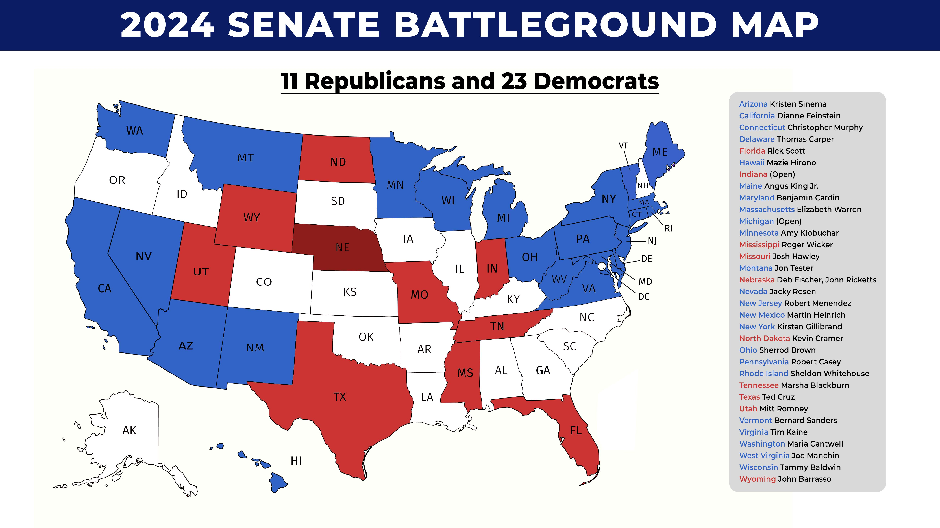
The NRSC remains laser-focused on recruiting candidates and helping build campaigns capable of winning a primary and a general election.
We are making encouraging recruitment progress in Montana, Ohio and West Virginia, and high caliber potential candidates are beginning public, and not yet public, exploration in multiple battleground states.

Senate candidates only have one chance to make a good first impression, and that is why the NRSC is offering media training and self-vets for all Senate candidates before they launch their campaigns. Success in November 2024 begins with each potential Republican nominee honing a winning message and being disciplined messengers. It is also imperative that Republican candidates know their vulnerabilities, and there are no surprises during the heat of the fall campaign. The NRSC has doubled its investment in opposition research, and we are already aggressively tracking Democrat candidates and placing research to hold Democrat candidates accountable for their corruption, hypocrisy and extreme positions on the issues.

The hard-dollar fundraising disparity was a major impediment to winning a Republican Senate majority in 2022. In response, the NRSC is prioritizing getting more hard dollars to our Republican nominees. We’ve reduced NRSC overhead by 15 percent, and we’re using our large, small donor list to conduit donations to Senate candidates – who can spend the money more efficiently than outside entities can. We’ve launched Senate24.com for our Majority Makers program, which is being chaired by Senator Lindsey Graham and builds a small dollar donor fund for our eventual nominees in Montana, Ohio and West Virginia. Additionally, the NRSC launched our Targeted State Victory Joint Fundraising Committee months earlier than historically has been the case as we work to build significant resources for turnout operations, including early and absentee voting.

The NRSC is also implementing a campaign certification program to ensure all our eventual nominees are building the organization required for success beyond the primary. We are working to develop a collaborative relationship with each campaign that adds value and helps our eventual nominee build for general election success.

Finally, we are working with campaigns, state parties and the RNC to build a turnout operation focused on Election Month, not just Election Day. Republicans can compete with Democrats in mail-in balloting and early voting, we just need to dedicate real resources to the efforts and aggressively communicate with Republican voters on the importance of getting their ballots cast to ensure they are counted.

MONTANA – SENATOR JON TESTER
2020 Senate: Steve Daines (R) 55% +10%  Steve Bullock (D) 45%  2020 President: Donald Trump (R) 56.9% +16.3%  Joe Biden (D) 40.6%  2018 Senate: Jon Tester (D) 50.3% +3.5%  Matt Rosendale (R) 46.8%  2016 President: Donald Trump (R) 56.5% (+20.6)  Hillary Clinton (D) 35.9% | 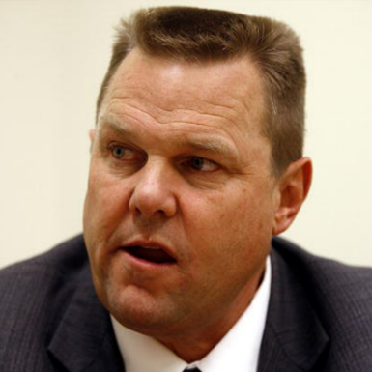  Tester 2018 Raised:  $19,757,019  Tester Q1 2023 CoH:  $7,034,292.55  Primary Date: June 4, 2024
Montana is a state that voted for Bill Clinton in 1992 but has otherwise been voting Republican for President back to the 1960’s. Senator Tester has won in the past by pledging to do things differently and remain true to Montana values. But a state that has been going double-digit red for quite some time will reject his 91% support for Biden’s agenda. Montana has become increasingly red in recent years. Tester is the lone Democrat in statewide office, and Republicans have supermajorities in the legislature. The shift is demonstrated by primary turnout. In 2018, of all primary votes cast, 42.8% in the Democratic primary and 57.2% in the Republican primary. In 2022, 34.2% were cast in the Democratic primary and 65.8% were cast in the Republican primary. That’s a 14.4% primary advantage in 2018 to a 31.6% primary advantage in 2022.

Recent Polling & Data:

- On Message (Feb. 18-21): Tester – 41%, Rosendale 46%
- Sabato’s Crystal Ball (Jan. 24): Toss-up
- The Political Company (Jan. 30-Feb. 1): Tester – 45%, Gianforte – 45%; Tester – 45%, Rosendale – 40%; Tester – 46%, Zinke – 40%

Media Spending: The NRSC released an ad blasting Jon Tester for voting to put Medicare and Social Security at risk. The NRSC previously rolled out a video targeting Tester as part of its “Retire or Get Fired” campaign.

Recent Headlines & Hits:

- Fox News: Democrat senator slapped with ethics complaint for using official website to push re-election campaign
- KMMS 1450 AM: Will This Navy SEAL Rescue Montana From Jon Tester?
- Fox News: Dems who voted to roll back bank regulations in 2018 took campaign cash from Silicon Valley Bank, lobbyists
- Fox News: Combat veteran mulling Montana GOP Senate bid criticizes Democratic Sen. Tester’s 'farting around' comment
- Fox News: Democrats’ comments on Chinese spy balloon did not age well after report of real-time intelligence gathering

WEST VIRGINIA – SENATOR JOE MANCHIN

2020 Senate: Shelley Moore Capito 70.3% +43.3%  Paula Jean Swearengin (D) 27%  2020 President: Donald Trump 68.6% +38.9%  Joe Biden (D) 29.7%  2018 Senate: Joe Manchin (D) 49.6% +3.3%  Patrick Morrisey (R) 46.3%  2016 President: Donald Trump (R) 67.9% +41.7%  Hillary Clinton (D) 26.2% | 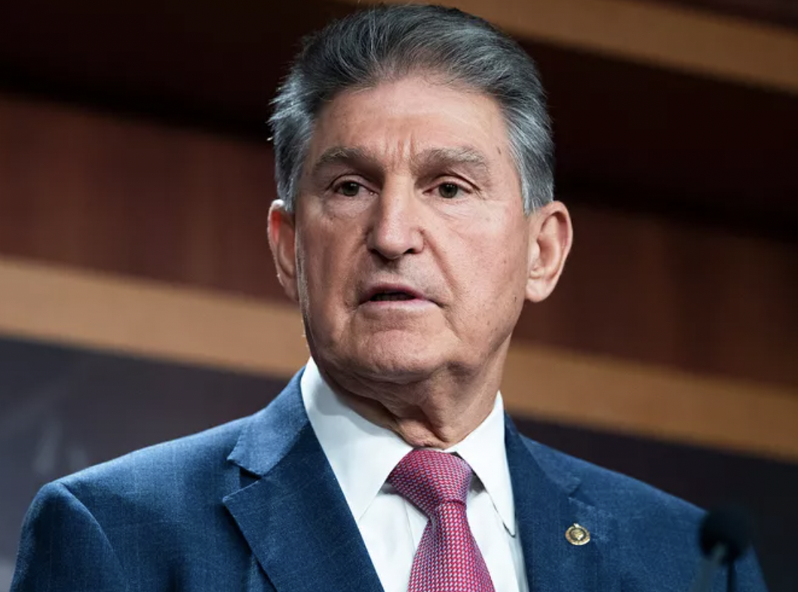  Manchin 2018 Raised:  $9,375,411  Manchin Q1 2023 CoH:  $9,706,927.82  Primary Date: May 14, 2024

West Virginia is the top pick-up opportunity in 2024. Whether Manchin retires, or runs again, Democrats will be faced with running down ballot from a 40-point defeat in the presidential election. West Virginia has shifted hard to the right in the past two decades eliminating all Democrats from statewide office other than Manchin and giving Republicans supermajorities in the state legislature. Manchin barely survived in 2018, and in 2024, he faces a starkly different environment and electorate than the last time he ran on a presidential ballot in 2012. West Virginia went from 32.4% GOP – 41.9% Dem (a 9.5% Democrat registration advantage) in 2018 to 39.0% GOP – 33.4% Dem (5.6% advantage for Republicans) today.

Recent Polling & Data:
- National Public Affairs (March 14-17): Justice – 43%, Morrisey – 21%, Mooney – 10%, Rose – 2%
- Tarrance Group / Senate Leadership Fund (Feb. 5-7): Manchin – 42%, Justice – 52%; Manchin – 52%, Morrisey – 42%; Manchin – 55%, Mooney – 40%
- Sabato’s Crystal Ball (Jan. 24): Leans R
- The Cook Political Report (Jan. 24): Toss-up

Media Spending: The NRSC released an ad blasting Joe Manchin for voting to put Medicare and Social Security at risk. The NRSC also hit Manchin on his trip to Davos, Switzerland in a direct mail and digital ad campaign marking the Senator as “Maserati Manchin.” The NRSC previously rolled out a video targeting Manchin as part of its “Retire or Get Fired” campaign.

Recent Headlines & Hits:
- Fox News: Manchin’s wife broke 'conflicts of interest' ethics pledge, emails show
- POLITICO: Justice for Manchin: Senate Republicans closing in on 2024 recruit
- Daily Wire: GOP Has Formidable 2024 Opponent For Joe Manchin In Mind
- NBC News: Joe Manchin says he won't decide on 2024 until 'the end of the year'
- Fox News: First on Fox: West Virginia Attorney General Morrisey announces GOP run for governor
- NBC-Bluefield: On W.Va. Tour, Senator Manchin Takes Questions On Possible Presidential Bid, Justice Challenge
- Wall Street Journal: Joe Manchin Gets Another Blow
- West Virginia Metro News: Justice Says Announcement On Senate Run Coming Soon
- Washington Examiner: Club For Growth Endorses Mooney In 2024 West Virginia Senate Race As Justice Eyes Bid
- Business Insider: Sinema, Manchin got cash from GOP billionaire funding Clarence Thomas's vacations

OHIO – SENATOR SHERROD BROWN

2022 Senate: J.D. Vance (R) 53.3% +6.6%  Tim Ryan (D) 46.7%  2020 President: Donald Trump (R) 53.3% +8.1%  Joe Biden (R) 45.2%  2018 Senate: Sherrod Brown (D) 53.4% +6.8%  Jim Renacci (R) 46.6%  2016 President: Donald Trump (R) 51.7% +8.1%  Hillary Clinton (D) 43.6% | 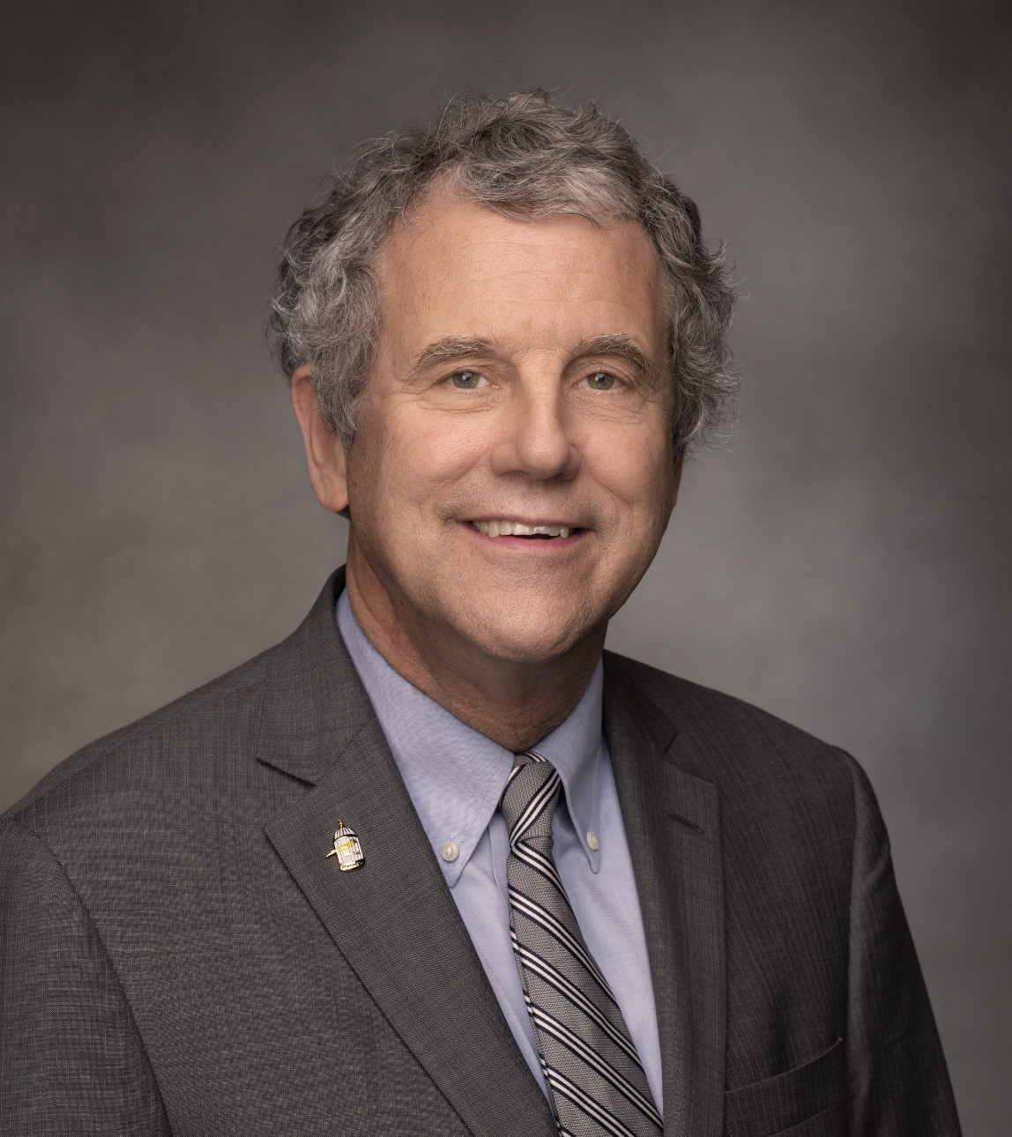  Brown 2018 Raised:  $27,840,436  Brown Q1 2023 CoH:  $5,820,131.46  Primary Date: March 19, 2024

Ohio is a top pick-up opportunity in 2024. The state has been trending strongly Republican in recent elections, and Brown benefitted from weak opposition and a bad Republican year in 2018. Brown is seeking re-election, but he will face headwinds requiring him to run 6 to 8 points ahead of the top of the ticket in a presidential year to be successful. Brown is a hardcore liberal and consistently votes for policies out of step with Ohio voters. The partisan shift toward Republicans in Ohio is demonstrated by primary turnout. In 2018, of all primary votes cast, 44.8% in the Democratic primary and 55.2% in the Republican primary. In 2022, 33.1% were cast in the Democratic primary and 66.9 were cast in the Republican primary. That’s a 14.4% primary advantage in 2018 to a 31.6% primary advantage in 2022.
Brown votes with Biden 99% of the time.

Recent Polling & Data:

- The Cook Political Report (Jan. 24): Toss-up
- Sabato’s Crystal Ball (Jan. 24): Toss-up

Media Spending: The NRSC released an ad blasting Sherrod Brown for voting to put Medicare and Social Security at risk. Matt Dolan also launched a digital ad campaign highlighting Sen. Brown’s liberal voting record and encouraging OH voters to go to BlindLoyaltyBrown.com. The NRSC previously rolled out a video targeting Brown as part of its “Retire or Get Fired” campaign.

Recent Headlines:

- NBC News: Republicans prepare for battle in the race to unseat Ohio Sen. Sherrod Brown
- Breitbart: Swing State Democrats Silent as Biden Considers Border Policy They Opposed Under Trump
- Fox News: First on Fox: Ohio GOP Senate candidate Matt Dolan visits US-Mexico border
- NBC News: Trump encourages Bernie Moreno Senate bid in Ohio
- Fox News: Democrats’ comments on Chinese spy balloon did not age well after report of real-time intelligence gathering
- NBC News: Bernie Moreno files paperwork to take on Sen. Sherrod Brown

ARIZONA – SENATOR KYRSTEN SINEMA (I)
2022 Senate: Mark Kelly 51.4% (D) +4.9%  Blake Masters 46.5% (R)  2020 President: Joe Biden (D) 49.4% +0.3%  Donald Trump (R) 49.1%  2018 Senate: Kyrsten Sinema (D) 50.0% +2.4%  Martha McSally (R) 47.6%  2016 President: Donald Trump (R) 48.1% +3.5%  Hillary Clinton (D) 44.6% | 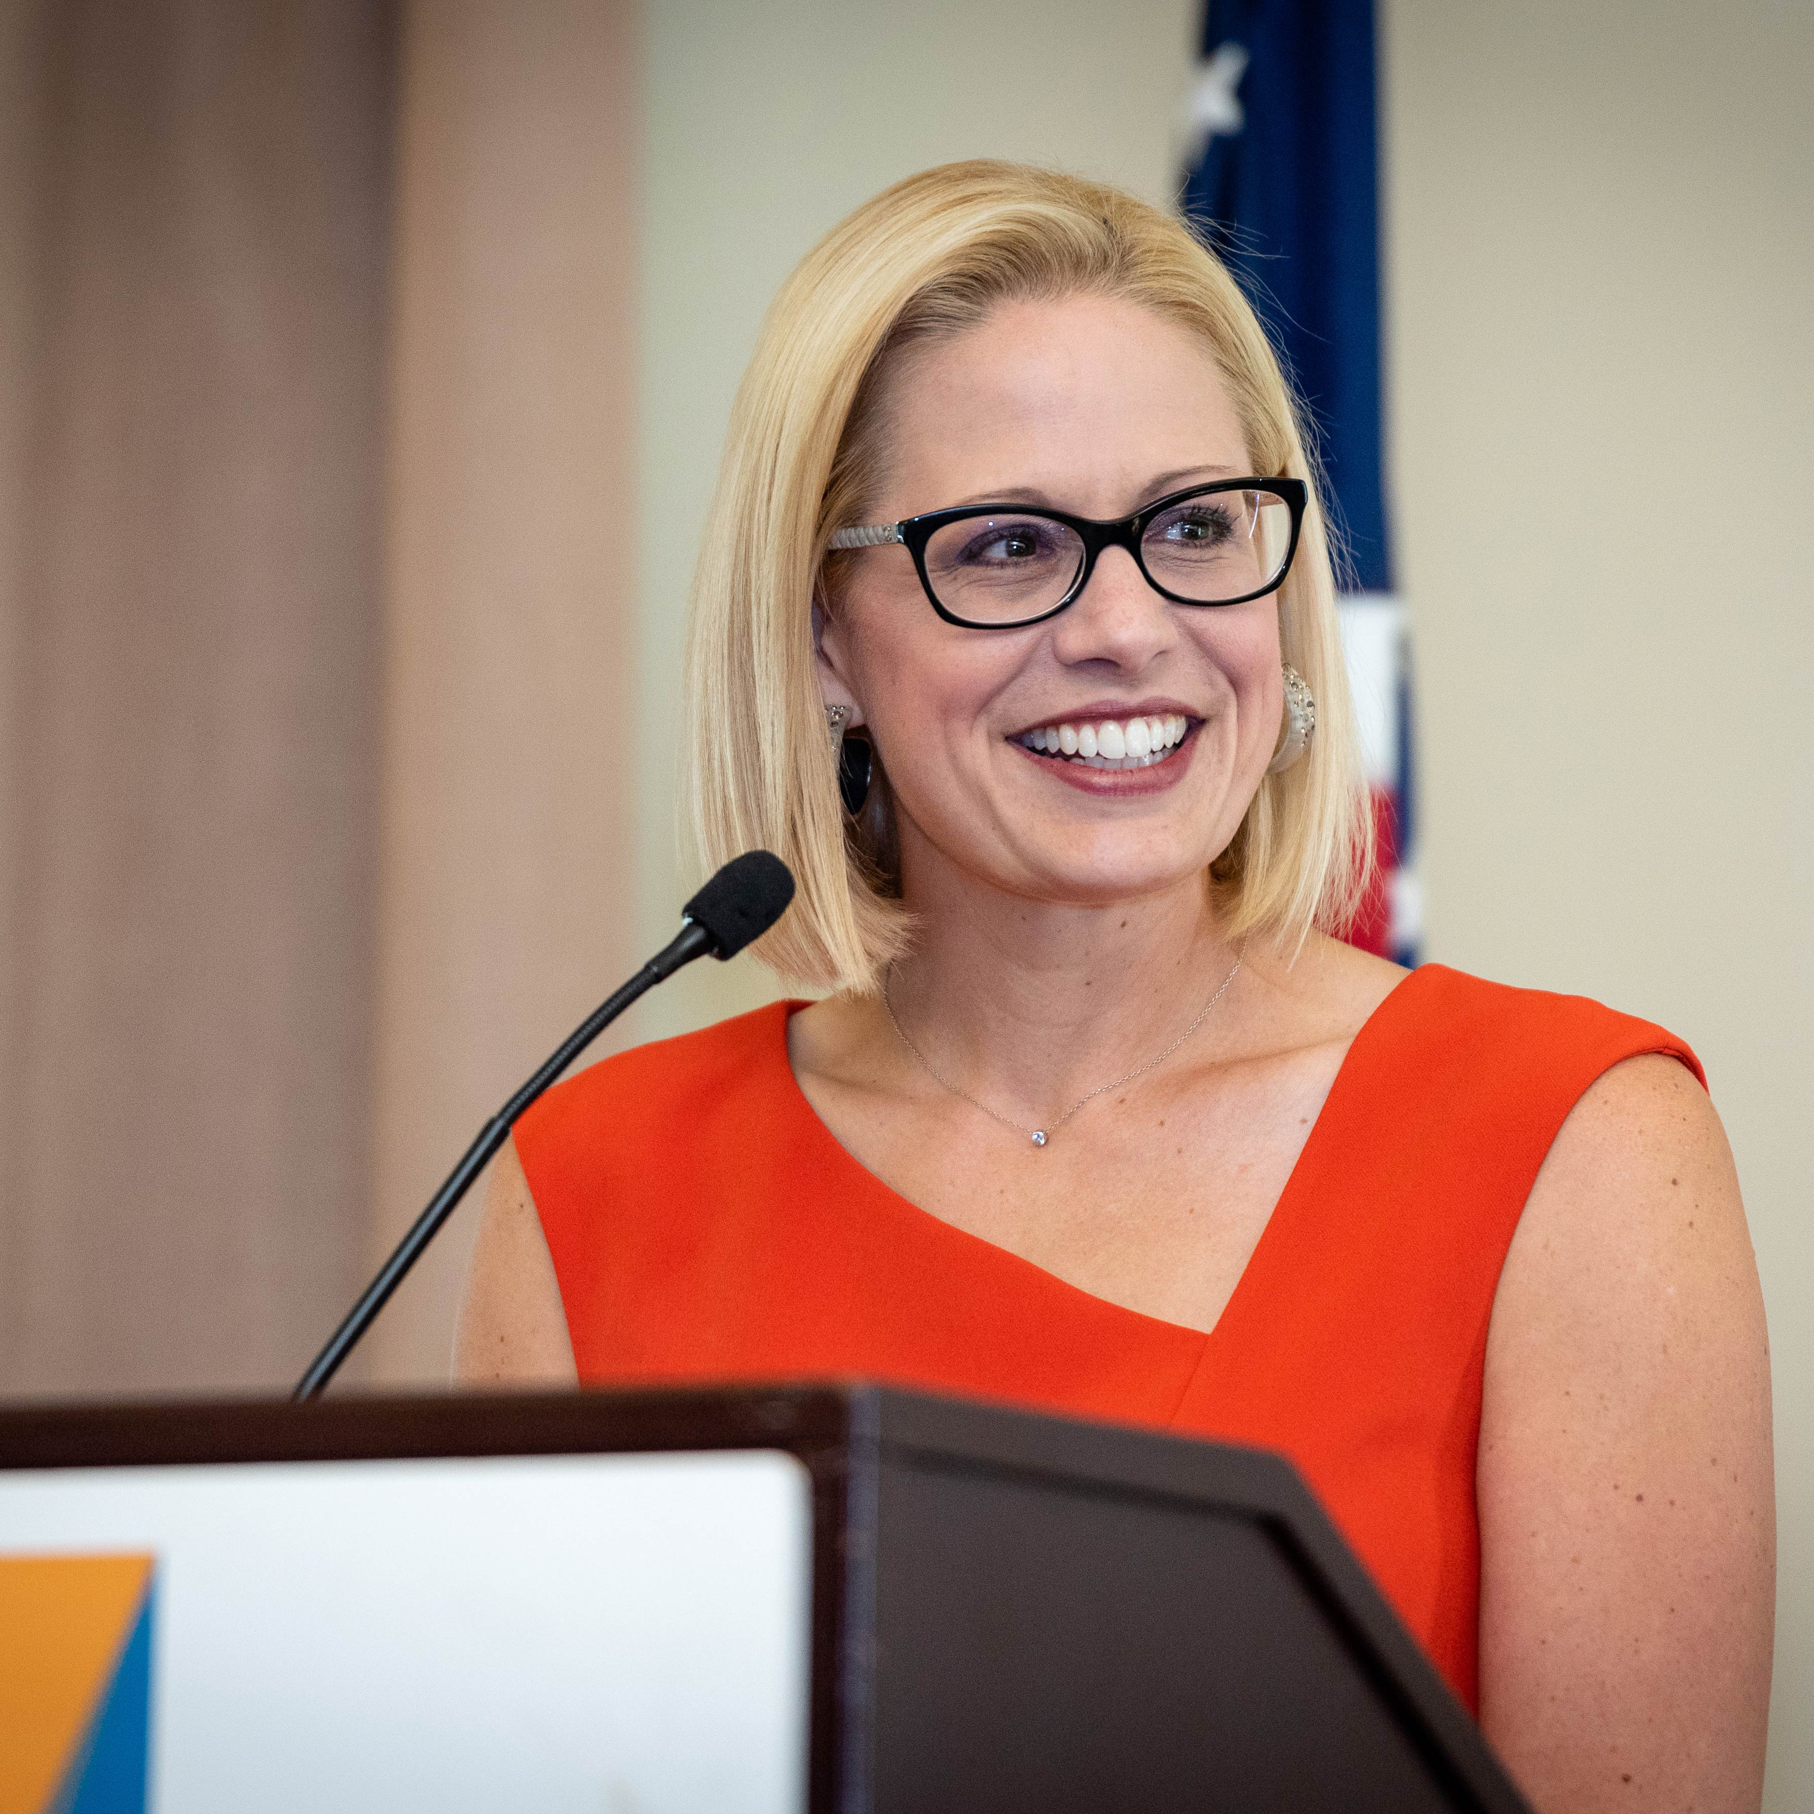  Sinema 2018 Raised:  $24,289,249  Sinema Q1 2023 CoH:  $9,946,954.90  Primary Date: August 6, 2024

Except for 1996 when it voted for Bill Clinton and 2020 when it very narrowly voted for Joe Biden, Arizona has otherwise been voting Republican for President back to the 50’s. But the elections of 2018, 2020 and 2022 show Arizona is now a very purple state, and the 2024 election will be competitive. Senator Sinema won her seat in 2018 in a very difficult year for Republicans and she has since broken with the radical left in her party on issues like ending the filibuster. This has earned Sinema enemies on the left, and her recent announcement she is an independent creates a huge opening for Republicans if we have a strong nominee.

Recent Polling & Data:

- OH Predictive Insights (Jan. 31 – Feb. 9): Gallego – 38%, Ducey –34%; Gallego – 36%, Taylor Robson – 32%; Gallego – 43%, Masters – 32%; Gallego – 43%, Lake – 33%; Gallego – 32%, Ducey – 27%, Sinema – 17%; Gallego – 31%, Taylor Robson – 24%, Sinema – 21%; Gallego – 33%, Masters – 24%, Sinema – 22%; Gallego – 34%, Lake – 26%, Sinema – 19%
- The Cook Political Report (Jan. 24): Toss-up
- Sabato’s Crystal Ball (Jan. 24): Toss-up

Recent Headlines & Hits:

- NBC News: Arizona county sheriff launches GOP Senate bid
- Fox News: Progressive Democrat Ruben Gallego blames 2018 bill for bank collapse despite wife's employer lobbying for it
- POLITICO: Sinema outraised by Gallego as reelection decision awaits
- AZ Central: Before Congress, Rep. Ruben Gallego boosted a migrant bank plan that crumbled
- POLITICO: Sinema Trashes Dems: ‘Old Dudes Eating Jell-O’
- Fox News: Democrats’ comments on Chinese spy balloon did not age well after report of real-time intelligence gathering
- Wall Street Journal: Kyrsten Sinema Is Preparing for a 2024 Re-Election Campaign as an Independent
- Business Insider: Sinema, Manchin got cash from GOP billionaire funding Clarence Thomas's vacations

INDIANA – OPEN

2022 Senate: Todd Young (R) 58.6% +20.7%  Tom McDermott (D) 37.9%  2020 President: Donald Trump (R) 57.0% +16%  Joe Biden (D) 41.0%  2018 Senate: Mike Braun (R) 50.7% +4.9%  Joe Donnelly (D) 44.8%  2016 President: Donald Trump (R) 57.1% +19.1%  Hillary Clinton (D) 38% | Primary Date: May 7, 2024

Indiana has become increasingly red since voting for Barack Obama in 2008. Republicans hold every statewide office and have supermajorities in both houses of the legislature. Senator Mike Braun chose to run for Governor rather than re-election. In 2024, the Republican nominee for President will win a strong double-digit victory and a Republican will hold this Senate seat.

Recent Polling & Data:

- The Cook Political Report (Jan. 24): Solid R
- Sabato’s Crystal Ball (Jan. 24): Safe R

Media: Rep. Jim Banks (R-IN-03) released a digital video titled “All in for Jim Banks.”

Recent Headlines & Hits:

- The Elkhart Truth: Banks launches tour in Goshen
- Washington Examiner: Jim Banks Picks Up Endorsement Of No. 2 Senate Republican

MICHIGAN - OPEN
2020 President: Joe Biden (D) 50.6% +2.8%  Donald Trump (R) 47.8%  2020 Senate: Gary Peters (D) 49.9% +1.7%  John James (R) 48.2%  2018 Senate: Debbie Stabenow (D) 52.3% +6.5  John James (R) 45.8%  2016 President: Donald Trump (R) 47.8% +.3%  Hillary Clinton (D) 47.5% | Primary Date: August 6, 2024
With Sen. Debbie Stabenow’s decision to retire, Michigan is now a top-tier Republican pickup opportunity. Despite a disappointing GOP performance in 2022, Michigan has been trending Republican in presidential elections, with Trump winning Michigan for Republicans in 2016 for the first time since 1988, and Trump narrowly losing in 2020 but by a narrow margin.

Recent Polling & Data:

- The Cook Political Report (Jan. 24): Lean D
- Sabato’s Crystal Ball (Jan. 24): Leans D

Recent Headlines & Hits:

- Breitbart: Slotkin: Judge Who Had Speech at Stanford Disrupted Was ‘a Little Bit of a Fragile Flower’
- POLITICO: Pamela Pugh, The President Of The Michigan State Board Of Education, Said She’s Considering A Run Against Elissa Slotkin And Other Dems For The Seat Held By Retiring Debbie Stabenow.

NEVADA – SENATOR JACKY ROSEN

2022 Senate: Catherine Cortez Masto (D) 48.7% +.5%  Adam Laxalt (R) 48.2%  2020 President: Joe Biden (D) 50.1% +2.4%  Donald Trump (R) 47.7%  2018 Senate: Jacky Rosen (D) 50.4% +5.0%  Dean Heller (R) 45.4%  2016 President: Hillary Clinton (D) 47.9% +2.4%  Donald Trump (R) 45.5% | 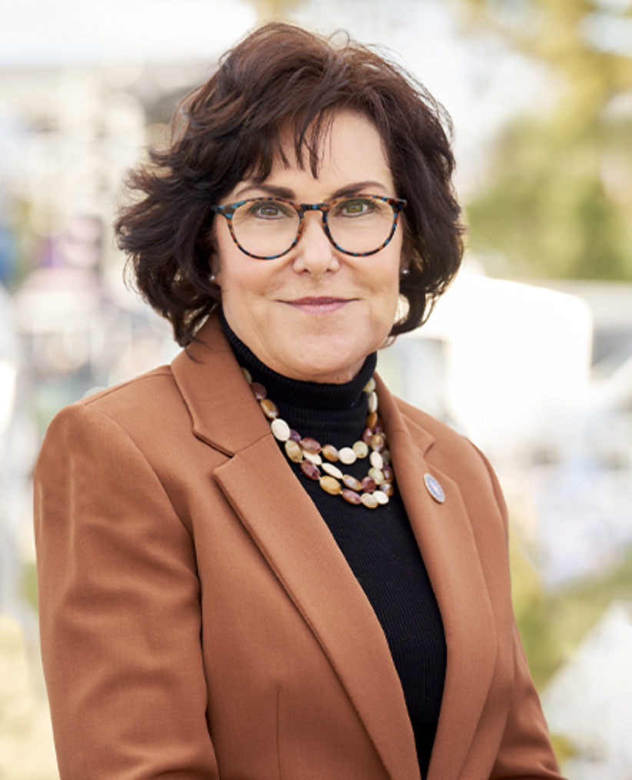  Rosen 2018 Raised:  $25,463,471  Rosen Q1 2023 CoH:  $6,032,902.12  Primary Date: June 11, 2024

Nevada is trending Republican in recent elections and will be a top-tier presidential battleground and pickup opportunity in 2024. Jacky Rosen officially announced she would run for re-election, but she has done little in the last four years to build support with Nevada voters. She has dutifully rubberstamped Biden’s agenda 93% of the time. A key to winning Nevada will be a strong nominee and a robust get-out-the-vote and vote by mail effort.

Recent Polling & Data:

- The Cook Political Report (Jan. 24): Lean D
- Sabato’s Crystal Ball (Jan. 24): Leans D
- OH Predictive Insights/The Nevada Independent (Jan. 30-Feb. 6) – President, General Election: Biden – 40%, Trump – 42%; Biden – 36%, DeSantis – 42%

Media Spending: The NRSC released an ad blasting Jacky Rosen for voting to put Medicare and Social Security at risk.

Recent Headlines:

- Newsweek: Nevada Top 2024 Battleground Target from Senate to President, GOP Says
- POLITICO: Nevada Sen. Jacky Rosen Announces 2024 Reelection Bid

PENNSYLVANIA – SENATOR BOB CASEY JR

2022 Senate: John Fetterman (D) 51.3% (+5%)  Mehmet Oz (R) 46.3%  2020 President: Joe Biden (D) 50.0% +1.2%  Donald Trump (R) 48.8%  2018 Senate: Bob Casey, Jr. (D) 55.7% +13.1  Lou Barletta (R) 42.6%  2016 President: Donald Trump (R) 48.2% +0.7%  Hillary Clinton (D) 47.5% | 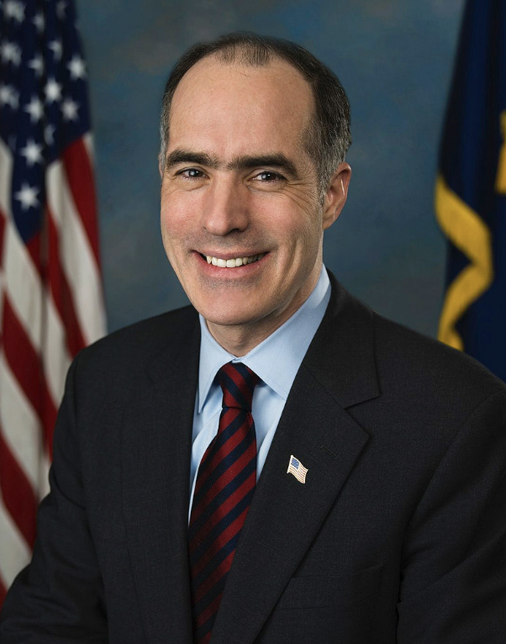  Casey 2018 Raised:  $20,888,608  Casey Q1 2023 CoH:  $3,237,732.29  Primary Date: April 23, 2024

Pennsylvania will be a top-tier presidential battleground in 2024, and with a strong Republican nominee, it will be a top-tier pickup opportunity. The last two presidential races have been decided by less than 2 points. Senator Casey formally announced he would seek reelection in April. Pennsylvania is an expensive state to run in and Republicans need a strong candidate capable of raising money and contributing money to put this seat in play.

Primary Date: April 23, 2024

Recent Polling & Data:

- Public Opinion Strategies (April 11 – 13): Biden – 46%, Trump – 42%; Biden 42%, DeSantis – 45%
- Franklin & Marshall College (March 27 – April 7): Casey – 47%, Mastriano – 31%; Casey – 42%, McCormick – 35%
- The Cook Political Report (Jan. 24): Lean D
- Sabato’s Crystal Ball (Jan. 24): Likely D

Media Spending: The NRSC released an ad “Caught” calling out Casey’s shady self-dealing. The NRSC previously released an ad blasting Bob Casey for voting to put Medicare and Social Security at risk.

Recent Headlines & Hits:

- Fox News: Senate GOP campaign arm targets Democratic Sen. Casey in battleground Pennsylvania's crucial race
- Breitbart: Watch: Republican Group Hammers Democrat Sen. Bob Casey’s ‘Self-Dealing’
- New York Post: Sen. Bob Casey oversaw Pa. pension investment in China-linked firm
- PoliticsPA: Sen. Bob Casey Launches Reelection Bid
- WTAJ: Dave McCormick discusses potential 2024 Senate run, Trump on This Week in Pennsylvania
- Breitbart: Swing State Democrats Silent as Biden Considers Border Policy They Opposed Under Trump
- Broad+Liberty: Sen. Casey tight-lipped over potential stock sale reporting violation
- Breitbart: Exclusive: Pennsylvania Republican Dave McCormick Lays Out Vision To ‘Confront China And Secure America’

TEXAS – SENATOR TED CRUZ

2020 Senate: John Cornyn (R) 53.5% +9.6%  MJ Hegar (D) 43.9%  2020 President: Donald Trump (R) 52.1% +5.6%  Joe Biden (D) 46.5%  2018 Senate: Ted Cruz (R) 50.9% +2.6%  Beto O’Rourke +48.3%  2016 President: Donald Trump (R) 52.2% +9%  Hillary Clinton(D) 43.2% | 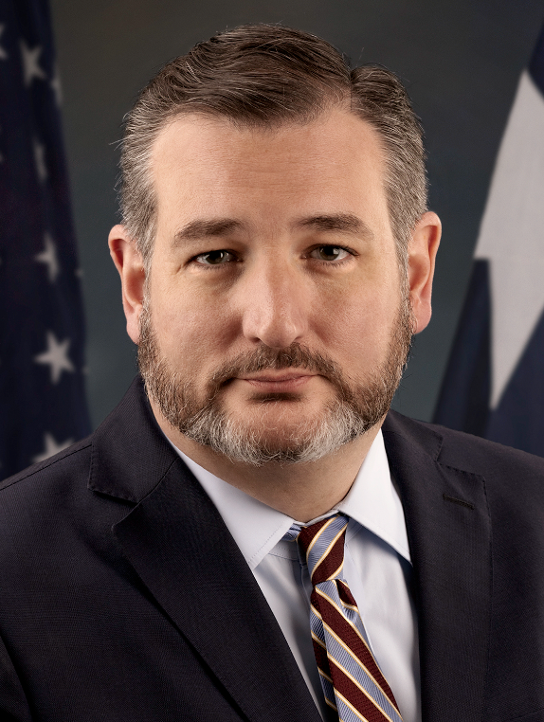  Cruz 2018 Raised:  $45,582,260  Cruz Q1 2023 CoH:  $3,314,483.18  Primary Date: March 5, 2024

Texas is a very difficult state for Democrats to go on offense, especially with the shifting party affiliation of Hispanic voters in the Rio Grande Valley, the enormous cost of advertising statewide, and the substantial likelihood the Republican nominee for President will win Texas by 6 to 8 points. Senator Cruz will have a strong, well-funded campaign. After concerns in 2018 that Texas was becoming purple, subsequent elections have shown it is still a red state.

Rumored Dem Candidates: Rep. Colin Allred (D-TX-32) – Q1 2023 COH: $2,239,859.66; former HUD Secretary Julian Castro, Rep. Joaquin Castro (D-TX-20) – Q1 2023 COH: $134,800.31; Former Representative and Senate candidate Beto O’Rourke; Astronaut Scott Kelly (Senator Mark Kelly’s twin brother)

Recent Polling & Data:

- The Cook Political Report (Jan. 24): Solid R
- Sabato’s Crystal Ball (Jan. 24): Likely R

WISCONSIN – SENATOR TAMMY BALDWIN

2022 Senate: Ron Johnson (R) 50.4% (+1)  Mandela Barnes (D) 49.4%  2020 President: Joe Biden (D) 49.5% +.7%  Donald Trump (R) 48.8%  2018 Senate: Tammy Baldwin 55.4% +9.9%  Leah Vukmir 44.5%  2016 President: Donald Trump (R) 47.2% +.7%  Hillary Clinton (D) 46.5% | 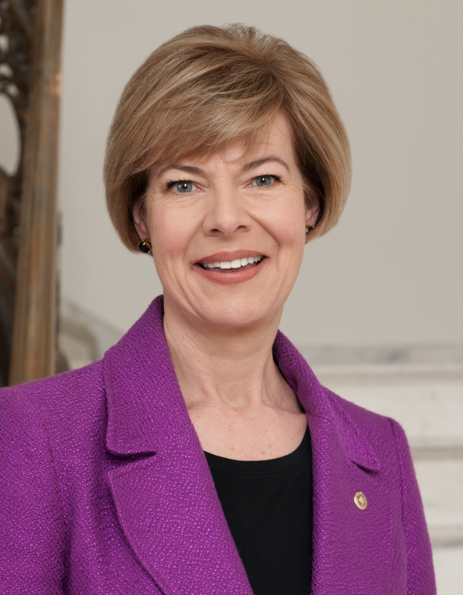  Baldwin 2018 Raised:  $30,932,923  Baldwin Q1 2023 CoH:  $3,895,781.33  Primary Date: August 13, 2024
Wisconsin will again be a top tier presidential battleground in 2024, and this will create the possibility to put the U.S. Senate seat held by Tammy Baldwin in play. Except for 2018, which was a very difficult mid-term year for Republicans, recent federal elections have been decided by a point or less. Baldwin announced she would seek reelection in April.

Recent Polling & Data:

- The Cook Political Report (Jan. 24): Lean D
- Sabato’s Crystal Ball (Jan. 24): Leans D

Incumbent Campaign: In 2018, Baldwin enjoyed a very favorable political environment in the most challenging environments for Republicans since 2006. In 2024, Baldwin will face a close presidential race at the top of the ticket and will have to defend Biden’s record which she rubberstamps 95% of the time.

Media Spending: The NRSC released an ad blasting Tammy Baldwin for voting to put Medicare and Social Security at risk.

